**Lab 5**

**To Demonstrate the Working of Binary Adders**

***Note: You may draw all the logic diagrams with hand and paste the pictures here or on logicly software with your name, roll number & section mentioned in your workspace. Make sure that all of your connections are clearly visible and distinguishable.***

**Tasks**

1. **Construct a logic circuit for half and full adder with the help of truth table. Also write the Boolean expression for output(s).**

Half Adder

1. Truth Table

|  |  |  |  |
| --- | --- | --- | --- |
| A | B | SUM | Carry |
| 0 | 0 | 0 | 0 |
| 0 | 1 | 1 | 0 |
| 1 | 0 | 1 | 0 |
| 1 | 1 | 0 | 1 |

1. Boolean Expression (Simplified)

SUM (S) bit:

F1 = A⊕B = A XOR B

CARRY-OUT (Cout) bit:

F2 = A.B = A AND B

1. Logic Diagram

**A**

**SUM**

Half Adder

**B**

**Carry**

1. Software Simulation (Show here your results for each combination that gives a high output)

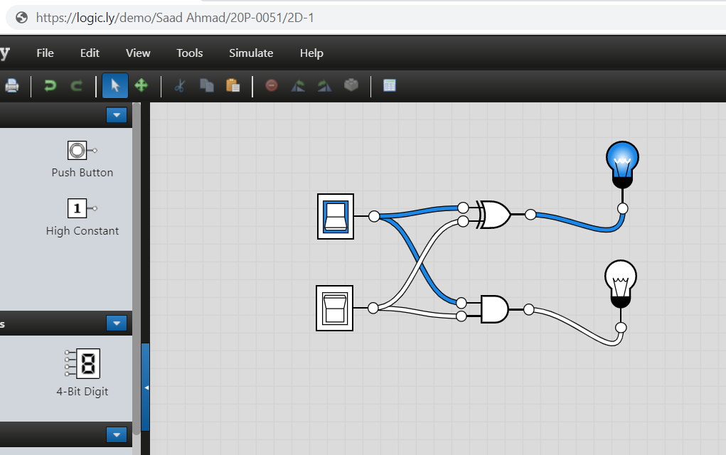

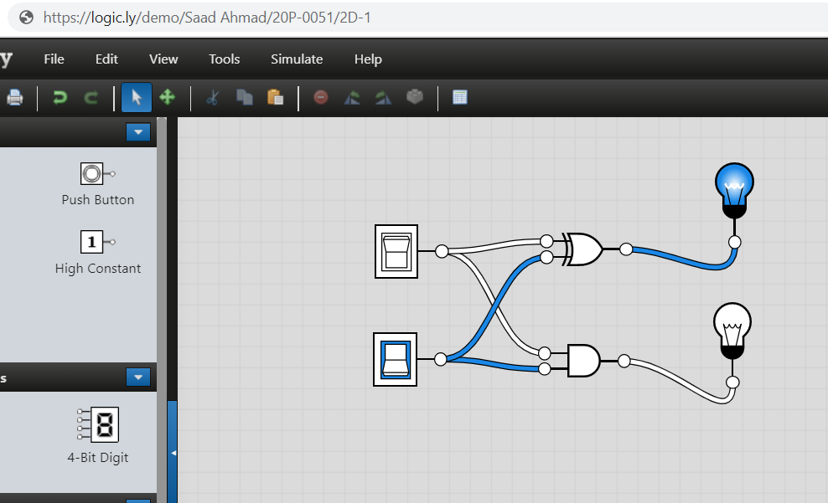

Full Adder

1. Truth Table

|  |  |  |  |  |
| --- | --- | --- | --- | --- |
| A | B | Cin | SUM | Cout |
| 0 | 0 | 0 | 0 | 0 |
| 0 | 0 | 1 | 1 | 0 |
| 0 | 1 | 0 | 1 | 0 |
| 0 | 1 | 1 | 0 | 1 |
| 1 | 0 | 0 | 1 | 0 |
| 1 | 0 | 1 | 0 | 1 |
| 1 | 1 | 0 | 0 | 1 |
| 1 | 1 | 1 | 1 | 1 |

1. Boolean Expression (Simplified)

SUM (S) bit:

F1 = (A ⊕ B) ⊕ Cin = (A XOR B) XOR Cin

CARRY-OUT (Cout) bit:

F2 = A.B + Cin (A ⊕ B) = A AND B OR Cin (A XOR B)

1. Logic Diagram

**A**

**SUM**

**B**

Full Adder

**Cin**

**Cout**

1. Software Simulation (Show here your results for each combination that gives a high output)

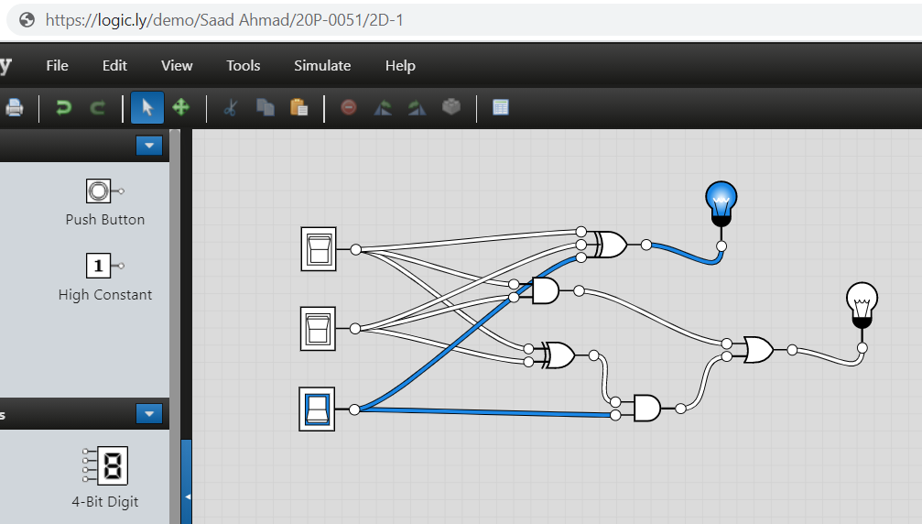

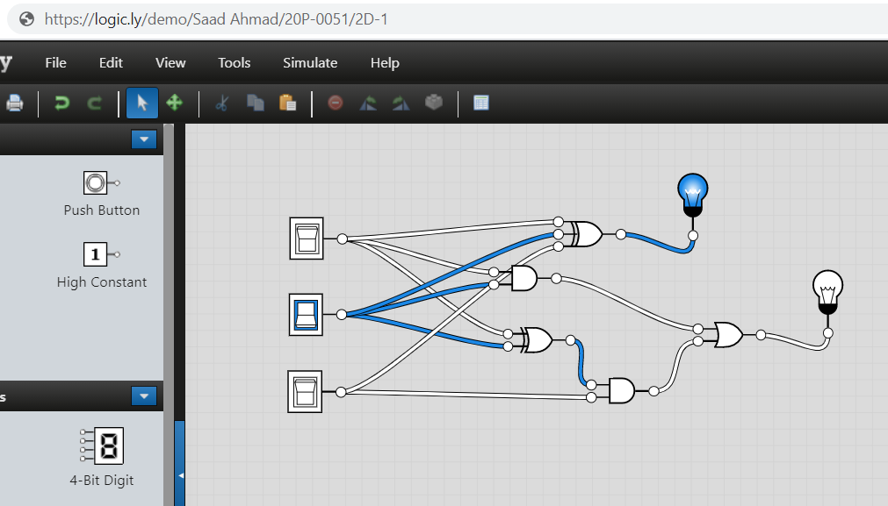

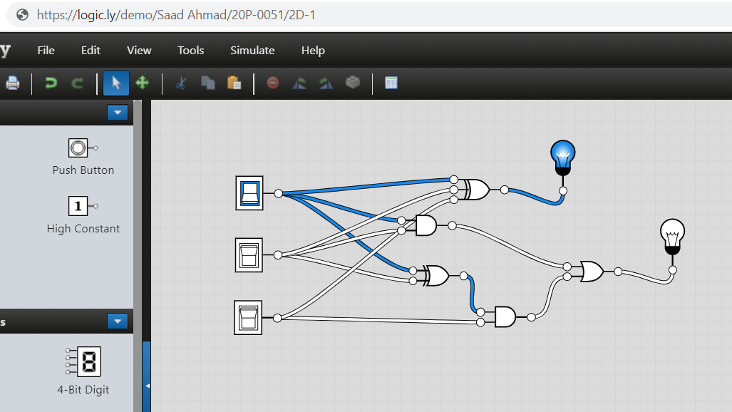

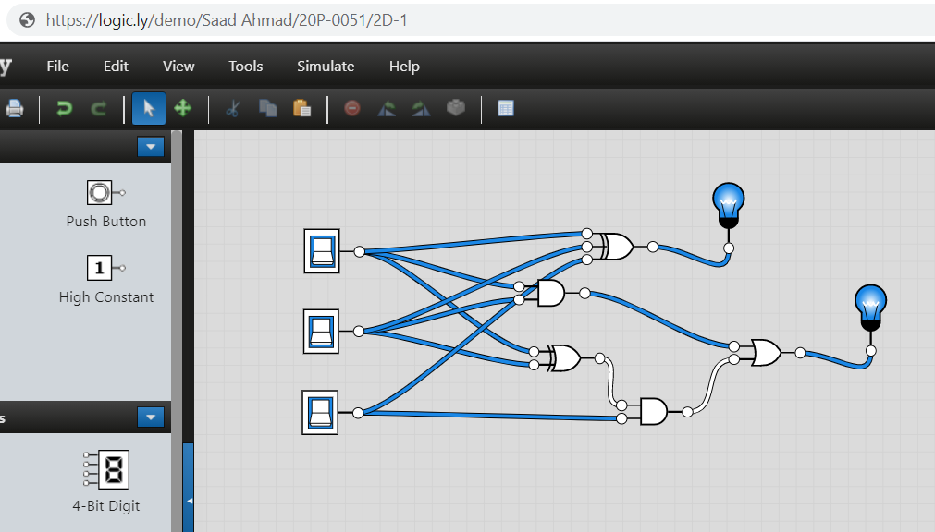

1. **A full adder can be implemented using 2-half adders. Demonstrate the logic diagram for the said circuit. Simulate your circuit for the verification of results.**
2. Logic Diagram of Full Adder using 2-Half Adders

Full Adder

**SUM**

**(A XOR B)XOR Cin**

Half Adder

Half Adder

**A XOR B**

**A**

Sum

Carry

Sum

Carry

**B**

**Cin (A XOR B)**

**A.B**

**Cout**

**Cin**

1. Software Simulation (Show here your results for each combination that gives a high output)

